SIMATS ENGINEERING (SAVEETHA SCHOOL OF ENGINEERING)
Department of Computer Science and Engineering
CO4 ASSESSMENT TOOL 2 – CI/CD Pipeline Design Exercise
Course Code: | CSA10 | Course Title: | Software Engineering
CO Assessed: | CO4 | Assessment: | Assessment Tool 2 – CI/CD Pipeline Design Exercise
Weightage: | 20% | Total Marks: | 25
CO4 Statement: | Implement robust testing, quality assurance, and DevOps practices, emphasizing security, reliability, and ethics.
Student Name: | P. Pawan Teja | Reg. No.: | 192372303
Date: | 21/08/2026 | Duration: | 60 minutes

Code of Conduct
I P. Pawan Teja / 192372303 (Name / Reg No) certify that this submission is my original work and that I have adhered to the guidelines specified for this assessment. I understand that any violation of academic integrity rules will result in disciplinary action.
Signature of the Student: Pawan Teja

Annexure A – CI/CD Pipeline Design Exercise

Instructions to Students
Each student is assigned an individual problem statement. Based on the assigned problem statement, design a CI/CD (Continuous Integration and Continuous Deployment) pipeline for the proposed software system to automate the processes of code integration, building, testing, and deployment.
The exercise should include:
- Analyze the project requirements and identify the CI/CD needs of the assigned problem statement.
- Design the CI/CD pipeline workflow showing stages such as source code management, build, testing, code quality analysis, packaging, and deployment.
- Identify suitable tools and technologies for each stage of the pipeline and justify their selection.
- Define appropriate automated testing strategies to be integrated into the pipeline.
- Design the deployment strategy, including development, testing/staging, and production environments.
- Incorporate appropriate security, quality checks, notifications, and rollback mechanisms in the pipeline.
- Prepare a CI/CD pipeline diagram and explain the workflow from code commit to deployment.
Deliverable: Submit a CI/CD Pipeline Design document containing the pipeline architecture/diagram, stages, tools, configuration/workflow, testing strategy, deployment process, and justification based on the assigned problem statement.

Assigned Problem Statement 8: Smart Building Occupancy Prediction and Space Utilization Platform

Industry Context
Commercial buildings, educational institutions, and corporate offices require intelligent space management to improve energy efficiency and optimize facility utilization. AI, IoT occupancy sensors, and cloud analytics enable organizations to understand occupancy trends and manage building resources efficiently.

Problem Statement
Large buildings often experience inefficient utilization of meeting rooms, classrooms, and office spaces, leading to unnecessary energy consumption and increased operational costs. Manual monitoring methods fail to provide accurate occupancy information. An intelligent occupancy prediction platform should collect data from occupancy sensors, access control systems, and scheduling platforms to predict space usage. The system should optimize room allocation, reduce energy waste, and improve facility management decisions.

Objectives
- Monitor occupancy using IoT sensors.
- Predict future occupancy trends.
- Optimize room allocation.
- Reduce energy consumption.
- Generate occupancy analytics.
- Support smart HVAC control.
- Improve facility planning.
- Enhance building efficiency.

Expected Outcomes
- Better space utilization.
- Reduced operational costs.
- Improved energy efficiency.
- Accurate occupancy prediction.
- Enhanced facility management.
- Automated resource allocation.
- Increased user comfort.
- Sustainable building operations.

CI/CD Pipeline Design Document
System under design: Smart Building Occupancy Prediction and Space Utilization Platform.

1. Requirement & CI/CD Pipeline Analysis
The platform is a multi-microservice, IoT-integrated system with strict reliability, privacy, and near-real-time requirements. The following CI/CD needs were identified from the problem statement:
Need | Why it matters for this system
Frequent, safe releases | Prediction models, allocation rules, and HVAC-control logic are updated often; automated pipelines prevent manual-deployment errors across many microservices.
Multi-service architecture | Sensor ingestion, access-control integration, scheduling sync, prediction engine, allocation, HVAC control, analytics, and alerting are separate services requiring independent build/test/deploy.
Hardware/IoT integration risk | Sensor and HVAC-controller integrations must be validated with simulators before touching real building hardware — pipeline must gate deployment behind simulation tests.
Data & privacy sensitivity | Occupancy data requires encryption and anonymization checks; security scanning must be part of every build, not a manual afterthought.
High availability requirement | 99.9% uptime target (NFR) means deployments must use zero/low-downtime strategies (blue-green or canary) with automated rollback.
Multi-environment rollout | Changes must be verified in Dev and Staging (with simulated sensors/bookings) before reaching Production buildings.

2. Pipeline Architecture & Workflow
The pipeline below covers code commit through production deployment. Stages 1–5 run on every commit/PR (Continuous Integration); stages 6–10 handle promotion across environments (Continuous Deployment) with an automated rollback loop.
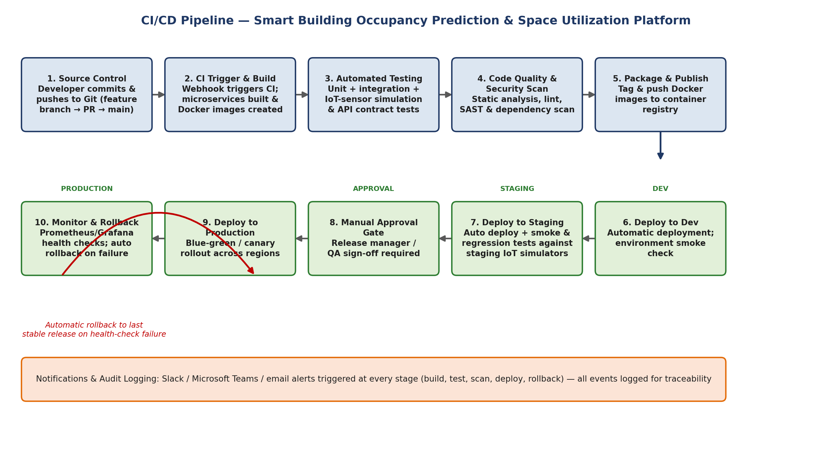
Workflow explanation:
- Commit & Trigger: a developer pushes to a feature branch and opens a PR; a merge to `develop` or `main` triggers the CI pipeline via a GitHub webhook.
- Build: each affected microservice is compiled/packaged and a Docker image is built.
- Automated Testing: unit, integration, and API-contract tests run against the freshly built images.
- Code Quality & Security Scan: SonarQube quality gate plus Trivy/Snyk vulnerability scans must pass before proceeding.
- Package & Publish: images that pass all gates are tagged with the commit SHA and pushed to the container registry.
- Deploy to Dev → Staging: automatic deployment with post-deploy smoke tests; Staging additionally runs the full regression suite and IoT-simulator tests.
- Manual Approval Gate: a Release Manager/QA lead reviews Staging results and approves promotion to Production.
- Deploy to Production: a blue-green/canary rollout gradually shifts real building traffic to the new version.
- Monitor & Rollback: Prometheus/Grafana continuously evaluate health; any failure automatically rolls the deployment back to the last stable release.
- Notifications & Audit Logging run in parallel with every stage, keeping the team informed and providing a full audit trail.

3. Tools & Technology Selection
Pipeline Stage / Concern | Tool(s) Selected | Justification
Source Control Management | Git + GitHub (with branch protection & PR reviews) | Industry-standard distributed VCS; GitHub Actions integrates natively for CI triggers and code review gating.
CI Orchestration | GitHub Actions (self-hosted runners for IoT simulators) | Tight Git integration, free for the scale needed, supports matrix builds for the multiple microservices.
Build & Containerization | Docker + Docker Compose | Each microservice (ingestion, prediction, allocation, HVAC-control, analytics) is packaged as an independent, reproducible container image.
Dependency/Package Management | npm / pip (per service) with lockfiles | Ensures reproducible builds and enables automated vulnerability scanning of dependencies.
Unit & Integration Testing | Jest / PyTest + Postman-Newman (API contract tests) | Widely adopted frameworks; Newman allows automated contract testing of REST APIs between services in CI.
IoT/Sensor Simulation Testing | Custom sensor-simulator harness (MQTT test broker) | Emulates occupancy sensor and HVAC controller behavior so hardware-dependent logic is verified without physical devices.
Code Quality Analysis | SonarQube | Detects code smells, duplication, and maintainability issues; enforces quality gates before merge.
Security Scanning | Trivy (container/image scan) + Snyk (dependency SCA) | Scans Docker images and dependencies for known CVEs before packaging; blocks pipeline on critical vulnerabilities.
Artifact/Container Registry | Docker Hub / Amazon ECR (private) | Central, versioned storage for built images consumed by all deployment stages.
Deployment Orchestration | Kubernetes (Helm charts) | Enables blue-green/canary rollout, auto-scaling for sensor ingestion load, and self-healing of failed pods.
Infrastructure as Code | Terraform | Provisions cloud infrastructure (compute, message broker, databases) consistently across Dev/Staging/Prod.
Monitoring & Alerting | Prometheus + Grafana | Real-time metrics on occupancy-ingestion latency, HVAC command success rate, and system health for rollback triggers.
Notifications | Slack / Microsoft Teams webhooks + email | Immediate visibility of pipeline status (build, test, scan, deploy, rollback) to the DevOps and facility-ops teams.
Secrets Management | HashiCorp Vault / GitHub Encrypted Secrets | Keeps API keys for scheduling/access-control integrations and cloud credentials out of source code.

4. Automated Testing Strategy
Test Type | When it Runs | Purpose | Tooling
Unit Tests | Every commit / PR | Validate individual functions: occupancy-count validation, prediction-model helper functions, allocation rule evaluators. | Jest (Node services), PyTest (prediction service)
Integration Tests | On merge to develop branch | Validate service-to-service communication: sensor ingestion → prediction engine → allocation service. | Postman/Newman, Testcontainers
API Contract Tests | On merge to develop branch | Ensure REST/MQTT message schemas between microservices remain backward compatible. | Pact / Newman contract suites
IoT Simulation Tests | Before Staging deployment | Simulate sensor and HVAC-controller traffic patterns (including offline/faulty sensor scenarios) against the built images. | Custom MQTT simulator harness
Security & Dependency Scans | On every build | Scan container images and dependencies for known vulnerabilities; block build on critical findings. | Trivy, Snyk
Code Quality Gate | On every PR | Enforce maintainability, duplication, and coverage thresholds before merge is allowed. | SonarQube Quality Gate
Smoke Tests | Immediately after each deployment (Dev/Staging/Prod) | Confirm core endpoints (health check, dashboard load, sensor ingestion) respond correctly post-deploy. | Automated smoke-test script in pipeline
Regression Tests | Before Production promotion | Re-run the full automated suite against Staging to catch regressions introduced since the last release. | CI regression job (full suite)
Load/Performance Tests | Scheduled (nightly) & pre-release | Validate NFR-01/NFR-02 (5-second refresh, 10,000 concurrent sensors) under simulated peak load. | k6 / Locust

5. Deployment Strategy — Environments
Environment | Promotion Trigger | Configuration | Purpose
Development | Auto-deploy on every successful merge to `develop` | Single-region, reduced-scale cluster; simulated sensors/bookings only | Fast feedback for engineers; no real building data
Staging | Auto-deploy after Dev smoke tests pass; requires regression suite pass | Mirrors Production topology; connected to sensor/HVAC simulators and a sandbox scheduling-platform account | Final verification ground before touching real buildings; used for load testing
Production | Manual approval gate + blue-green/canary rollout | Multi-region Kubernetes cluster serving real building sensors, access control, and HVAC systems | Canary receives 5–10% of building traffic first; promoted to 100% only after health checks pass for a soak period

6. Security & Quality Checks
- All inter-service and sensor-to-cloud traffic is encrypted in transit (TLS/MQTT-over-TLS) — verified by an automated config-check step in the pipeline.
- Container images are scanned (Trivy) and dependencies audited (Snyk) on every build; the pipeline fails the build on critical/high CVEs.
- Secrets (scheduling-platform API keys, cloud credentials) are injected at deploy time from a secrets manager — never committed to source control (enforced via a pre-commit/CI secret-scanning step).
- Role-based deployment permissions: only the Release Manager/DevOps role can approve the Production gate (aligned with FR-09 RBAC in the platform itself).
- Occupancy data anonymization checks run as part of the automated test suite to satisfy NFR-06 (data privacy) before every release.

7. Rollback & Monitoring Strategy
- Kubernetes readiness/liveness probes combined with Prometheus alerting continuously monitor post-deploy health (error rate, latency, HVAC-command failure rate).
- If health checks fail during the canary phase, the pipeline automatically halts traffic shift and reroutes 100% of traffic back to the last stable release (automated rollback — no manual step required).
- Every deployment is tagged and versioned in the container registry, so a rollback is simply re-pointing the Kubernetes deployment to the previous image tag (near-instant recovery).
- All rollback events trigger an immediate Slack/Teams notification and are logged for post-incident review.

8. Notifications
Slack and Microsoft Teams webhooks (with email as a fallback channel) notify the engineering and facility-operations teams at every key pipeline event: build failure, test failure, security-scan failure, successful deployment to each environment, approval-gate pending, and any rollback. Each notification links directly to the pipeline run for fast triage.

9. Summary
This CI/CD pipeline automates the journey from code commit to production deployment for the Smart Building Occupancy Prediction and Space Utilization Platform. It enforces automated testing (including IoT-sensor simulation), code-quality and security gates, a staged multi-environment rollout with a manual approval checkpoint before Production, and an automatic health-based rollback mechanism — directly supporting the system's reliability (99.9% uptime), security, and data-privacy requirements while enabling frequent, low-risk releases across its many microservices.

